June 2023

Online Consultation Management System

Synopsis

Submitted by

Mr. Ajay Kumar Sahu

In partial fulfillment for the award of the degree

Of

MCA_New(Master in Computer Application)

Indra Gandhi National Open University, New Delhi

**Online Consultation Management System**

**Introduction**-

Online doctor consultation is a innovative and convenient healthcare solution that leverages digital technology to connect patients with qualified healthcare professionals. It enables individuals to seek medical advice, diagnosis, and treatment recommendations from the comfort of their homes or wherever they may be, using secure and real-time communication channels such as video, audio, or text-based messaging. This transformative approach to healthcare aims to enhance accessibility, reduce wait times, and improve the overall patient experience, making quality medical care more accessible and efficient for all.

**Project Category**:RDBMS/OOPS

**Tools**

**1.4.1 Operating Environment**

OE-1: The online student registration system web application will operate with the following Web Browsers: Microsoft Internet Explorer version 5.0, 6.0. 7.0

OE-2: The online student registration system web application shall operate on a server running the latest versions of IIS (Internet Information Server).

OE-3: The online student registration system web application shall permit user access from Internet connection

OE-4: Operating System: Windows 10

OE-5: Software requirements: Visual Studio 2022 Community edition, MY SQL

OE-6: Languages used: .Net MVC,SQL,Bootstrap.

OE-7: Hardware Requirements: 8GB RAM(Minimum)

OE-8: Hard disc- nGB depending upon the requirement to store data minimum of 25GB.

**Problem Definition and scope of Project**

**Problem Definition**:

The problem you aim to address with an online doctor consultation project is to provide accessible and convenient healthcare services to patients through digital means. This project seeks to bridge the gap between patients and healthcare providers, ensuring that people can receive medical advice, diagnosis, and treatment recommendations without the need for physical visits to a medical facility. The key problems to address include:

1)Accessibility: Many individuals, especially those in remote or underserved areas, face challenges in accessing healthcare services. Online doctor consultation aims to make healthcare more accessible to everyone, regardless of their geographical location.

2)Convenience: Traditional in-person doctor visits often involve long wait times, travel, and time off work. An online consultation platform aims to provide a more convenient healthcare experience for patients, allowing them to seek medical advice from the comfort of their homes.

3)Timely Medical Care: In some cases, timely medical advice can be crucial. Online doctor consultations can facilitate rapid access to healthcare professionals, potentially preventing health conditions from worsening.

4)Healthcare Resource Optimization: By offering online consultations for non-emergency cases, this project can help reduce the burden on healthcare facilities, freeing up resources for critical care cases.

**Purpose of the Project:**

The purpose of an online doctor consultation project is multifaceted and encompasses various objectives and benefits, including:

* Increased Accessibility: To make healthcare services accessible to a broader population, including individuals in remote or underserved areas who may have limited access to medical facilities.
* Convenience: To provide a convenient alternative to traditional in-person doctor visits, reducing the need for travel and minimizing wait times.
* Timely Medical Care: To offer rapid access to healthcare professionals, ensuring that patients can receive medical advice and treatment recommendations promptly, potentially preventing the progression of health conditions.
* Optimized Resource Utilization: To alleviate the burden on physical healthcare facilities, particularly for non-emergency cases, thus optimizing resources and reducing overcrowding.
* Patient Privacy and Data Security: To prioritize patient data privacy and security by implementing robust encryption and compliance with data protection regulations.
* Effective Communication: To enable effective communication between patients and healthcare providers through secure video, audio, or text-based channels.
* Streamlined Appointment Management: To simplify appointment scheduling, allowing patients to choose preferred doctors and consultation types.
* Compliance with Telemedicine Regulations: To ensure compliance with local and national telemedicine regulations and standards, providing a legally sound platform.
* Electronic Prescriptions: To enable healthcare providers to electronically prescribe medications, enhancing patient convenience and safety.
* User Trust and Transparency: To establish a feedback and rating system that encourages trust andhelpspatientsmake informed choices when selecting healthcare providers.

**Scope of the Project**:

Platform Development: Create a user-friendly online platform (web or mobile application) that connects patients with healthcare providers. The platform should allow for secure, real-time video, audio, or text-based consultations.

The following features we want to avail for user:

* User is able to register and manage his profile.
* User can schedule appointment according to his choice.
* User with proper authentic username and password can only login.
* There should be proper facility for doctor and patient to upload all document related to consultation.
* Doctor should provide electronically prescribed medicine.

**Analysis**

**DFD(Data flow model)**

**Name:** Online Consultation Management System (DFD) Data Flow Diagram

**Abstract:** The doctor appointment management system data flow diagram (DFD) shows the structure of the project in terms of its data management. It contains the important details on the flow of data and alternatives done in the project**.**

**Diagram:** Data Flow Diagram (DFD)

**Users:** Hospital admin, Doctor and Patients.

**Level 0 DFD for Online Consultation Management System**

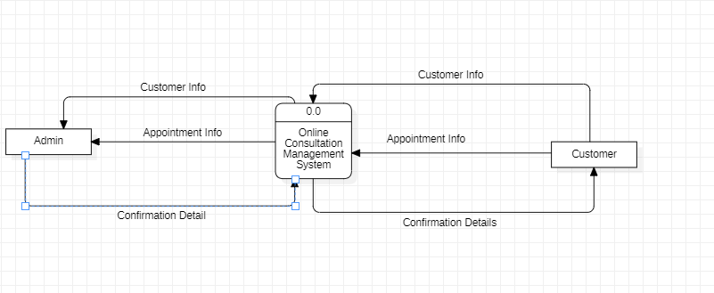

Level 1 for Online Consultation Management System

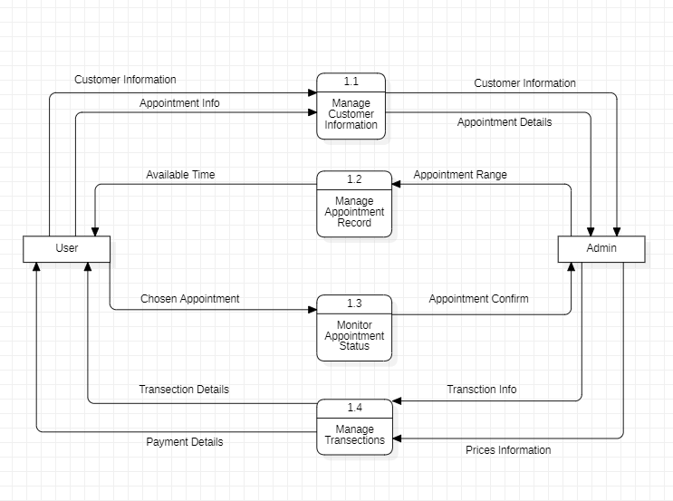

DFD Level 2 for Online Consultation Management System

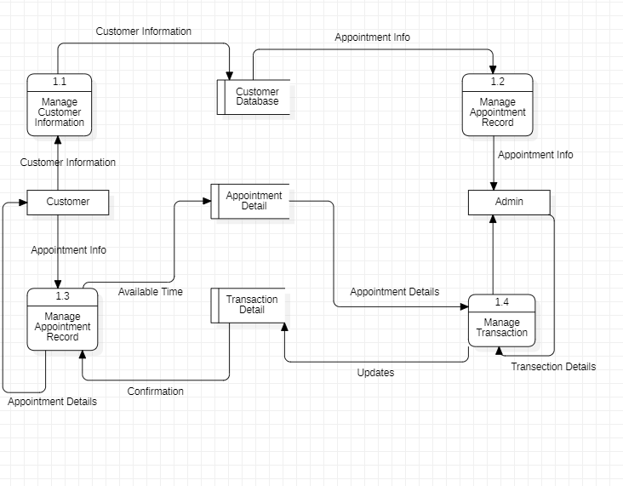

ER-Diagram

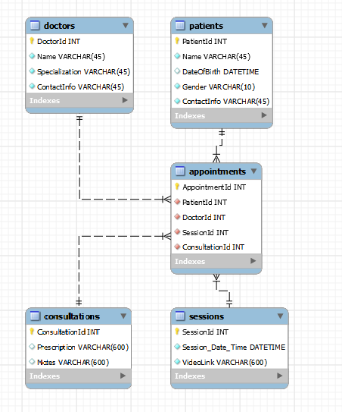

Complete Databases

Appointment Table

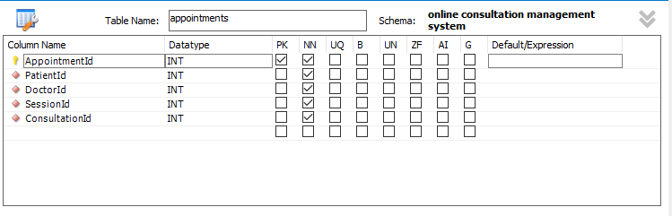

Foreign Keys

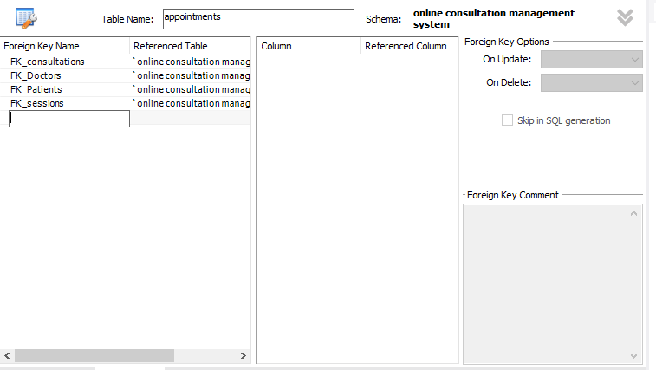

Consultation Table

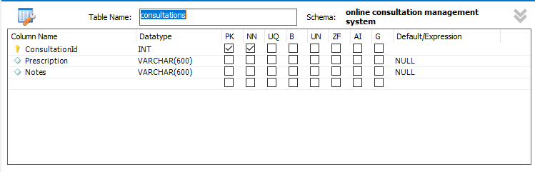

Doctors Table

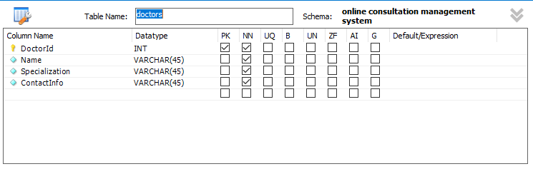

Patient Table

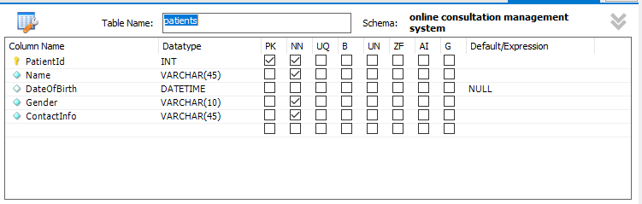

Sessions Table

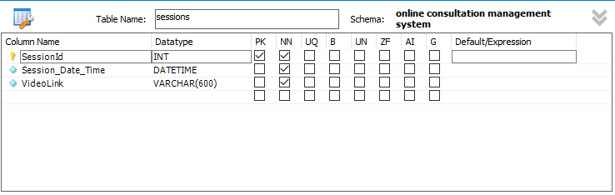

**Complete Structure**

**Modules of the project**

**User Registration and Profiles:**

Functionality: Implement a registration system allowing users (patients and healthcare providers) to create accounts.

Process Logic:

Registration: Users should be able to provide personal information (name, contact details) and medical information (medical history, current conditions).

Profile Management: Users should have the ability to manage and update their profiles, including any changes in personal or medical information.

**Appointment Scheduling:**

Appointment Booking: Develop a system that allows patients to schedule appointments with healthcare providers.

Process Logic:

Preferences: Include features for users to select preferred doctors, specify the consultation type (video, audio, or text), and choose suitable appointment times.

Notification: Provide a mechanism for both parties to receive notifications and reminders about upcoming appointments.

**Secure Communication:**

Encryption: Implement end-to-end encryption for communication channels to protect patient data and privacy.

Process Logic:

Authentication: Use secure authentication methods to verify the identity of users accessing the platform.

**Medical Records Management:**

Upload and Access: Allow patients and healthcare providers to securely upload and access medical records, test results, and prescriptions.

Process Logic

* Implement a structured system for organizing medical records, making it easy for users to locate and review relevant information.
* Provide version control for medical records to track changes and updates over time.

**Prescription:**

In these modules the doctor can upload prescription for patient to get medicated.

Process Logic:

Enable healthcare providers to electronically prescribe medications, ensuring accuracy and efficiency.

**Data structure**

**Appointments Table**

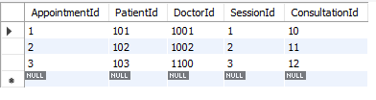

**Consultations Table**

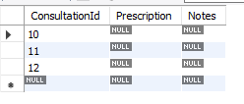

**Doctors Table**

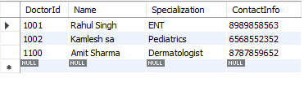

**Patients Table**

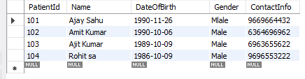

**Sessions Table**

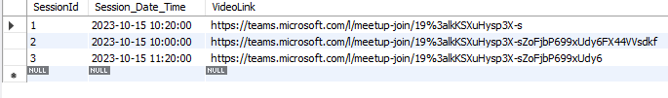

**Implementation of methodology**

Agile methodology

Agile methodology is a project management framework that breaks projects down into several dynamic phases, commonly known as sprints.

The Agile framework is an iterative methodology. After every sprint, teams reflect and look back to see if there was anything that could be improved so they can adjust their strategy for the next sprint.

**Implementation of security mechanisms at various levels**

Role-based access control (RBAC) is a method of regulating access to computer or network resources based on the roles of individual users within an organization. In the context of a healthcare system, such as a patient-doctor-hospital scenario, RBAC can be implemented through authentication and authorization mechanisms.

1. **Authentication:**
   * **Patient Authentication:** Patients need a secure way to verify their identity before accessing personal health information or performing any actions within the healthcare system. This authentication process could involve usernames and passwords, two-factor authentication, biometrics, or other secure methods.
   * **Doctor Authentication:** Similar to patients, doctors must authenticate themselves securely to access patient records, treatment plans, or other sensitive information. This may involve stronger authentication mechanisms due to the sensitivity of the data involved.
   * **Hospital Admin Authentication:** Hospital administrators, who oversee the overall system, should have robust authentication methods to access and manage the system settings, user roles, and other administrative functionalities.
2. **Authorization:**
   * **Patient Authorization:** Once authenticated, patients should have limited access to their own health records, appointment schedules, and possibly educational materials. They may not have access to sensitive administrative or medical information unrelated to their own treatment.
   * **Doctor Authorization:** Doctors, having more responsibilities, would be authorized to access patient records they are treating, update treatment plans, prescribe medications, and view relevant medical history. However, their access might be restricted from certain administrative functions.
   * **Hospital Admin Authorization:** Hospital administrators, with the highest level of authorization, would have access to the entire system. They can manage user roles, configure system settings, generate reports, and perform other administrative tasks critical for the smooth operation of the healthcare system.

Implementing RBAC ensures that individuals have the right level of access needed for their role, reducing the risk of unauthorized access or accidental data breaches. Regular review and updates to roles and permissions are also crucial to adapt to changes in the organization's structure or healthcare policies. This approach enhances security, privacy, and overall system efficiency in a healthcare environment.

**Future Scope of the project**

**Feedback and Ratings:**

Rating System: Integrate a rating system (e.g., on a scale of 1 to 5) to provide a quick overview of a healthcare provider's performance.

**Legal and Regulatory Compliance:**

Research and Adherence: Conduct thorough research on local and national healthcare regulations, data protection laws, and telemedicine guidelines. Implement systems and processes to ensure adherence to these regulations.

**Marketing and User Acquisition:**

Digital Marketing: Utilize digital marketing strategies such as social media advertising.

User Incentives: Offer incentives for both patients and healthcare providers to join and actively use the platform, such as discounts, promotional offers, or exclusive features.

**Customer Support:**

Issue Resolution: Establish a system for efficiently resolving user issues and collecting feedback to continuously improve customer support services.

**Continuous Improvement:**

Feedback Loops: Create mechanisms for users to provide feedback on their experiences and suggestions for improvement.

**Bibliography**

1. Ibrahim Al-Mahdi, Kathleen Gray, Reeva Lederman. Online Medical Consultation: A review of literature and practice, 2015. Available at: http://crpit.com/confpapers/CRPITV164AlMahdi.pdf. Accessed on 6 March, 2018

2.Edwards HB, Marques E, Hollingworth W, Horwood J, Farr M, Bernard E, et al. Use of a primary care online consultation system, by whom, when and why: evaluation of a pilot observational study in 36 general practices in South West England BMJ Open. 2017;7:e016901.

3.Slater C. The Doctor of the Future, 2013. Available at: http://www.fastcompany.com/1266043/doctorfuture. Accessed 20 January 2018.